# Goal

In this assignment we are going to try to create a basic calculator like the one found on your computer. Unlike many scientific calculators this one will only allow you to do one operation at a time (e.g. ) which allows you to not have to worry about order of operations (BEDMAS). If you are interested in creating a calculator that supports order of operations (also known as “infix”), I would suggest looking at the [Shunting Yard Algorithm by Edsger Dijkstra](https://en.wikipedia.org/wiki/Shunting-yard_algorithm).

The calculator should look something like this:

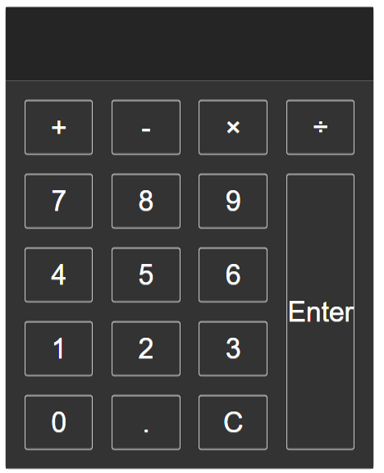

The calculator, at a minimum, needs to have:

* A way to enter the numbers
* A way to add a decimal
* The ability to do
  + Addition
  + Subtraction
  + Division
  + Multiplication
* A way to add a number to the stack (Enter)
* A way to clear the current textbox.

## Bonus

If you finish early, try to add some additional functions to the calculator (for example add the [modulo operator](https://en.wikipedia.org/wiki/Modulo_operation), which finds the remainder after a division e.g. ).

# General Instructions

## Create the HTML/CSS

1. Create the calculator HTML and CSS
2. The Calculator should be made up of at least 17 buttons and 1 input field.
3. Assign a class to each type of button and field (e.g. number, decimal, operator, clear, enter)
4. Design the basic layout of the calculator and figure out how you would need to divide up all the tags so it would look proper.
5. Change the coloring of the calculator so it looks good.

## Create the JavaScript

1. Create a Calculator object that will change the attributes of the CSS
2. Create the following function
   1. **clear** – Clears the screen
   2. **enter** – Adds the input to the stack
   3. **numberHandle** – Handles the input of a number
   4. **operatorHandle** – Handles the input of an operator ()
   5. **decimalHandle** – Handles the input of a decimal
   6. **calculate** – Main function which handles inputs
   7. **calculateValue** – Does the math when you press enter
   8. **storeNumber** and **storeOperator** – Optional functions to store the values cleaner

## Functions You May Need

// General Functions and Objects //

document.addEventListener();

document.getElementsByClassName();

target.classList.contains();

console.log();

String()

parseInt()